**Luke Pepin - CSE3300: Computer Networking**

Homework 6

Due Date: Tuesday, November 19, 2024. Submission through HuskyCT. Full score: 100 for CSE3300 students; 120 for CSE5299 students (will be normalized to 100 when entering the grade in HuskyCT).

1. **Subnet Address (15 points).** Consider a router that interconnects three subnets: Subnet 1, Subnet 2, and Subnet 3. Suppose all of the interfaces in each of these three subnets are required to have the prefix 137.99.17/24. Also suppose that Subnet 1 is required to support up to 80 interfaces, and Subnet 2 and 3 are each required to support up to 40 interfaces. Provide three network addresses (of the form a.b.c.d/x) that satisfy these constraints. Please justify that your design works, i.e., the address blocks of the three subnets do not have any overlap, the address block of each of three subnets is within 137.99.17/24, and each of the subnets has a sufficient number of IP addresses.

Subnet 1:

Requirements:

* 80 interfaces (specified in problem statement) + 2 ( additional network and broadcast addresses) = 82, smallest power to 2 that is greater than 82 is 128, thus /25 subnet
* 137.99.17 is specifed in problem statement

Address: 137.99.17.0/25

Range: 137.99.17.0 to 137.99.17.127

Subnet 2:

Requirements:

* 40 interfaces (specified in problem statement) + 2 ( additional network and broadcast addresses) = 42, smallest power to 2 that is greater than 42 is 64, thus /26 subnet
* 137.99.17.128 is specifed in problem statement + begins where subnet 1 ends

Address: 137.99.17.128/26

Range: 137.99.17.128 to 137.99.17.191

Subnet 3:

Requirements:

* 40 interfaces (specified in problem statement) + 2 ( additional network and broadcast addresses) = 42, smallest power to 2 that is greater than 42 is 64, thus /26 subnet
* 137.99.17.192 is specifed in problem statement + begins where subnet 2 ends

Address: 137.99.17.192/26

Range: 137.99.17.192 to 137.99.17.255

Conclusion:

This design works as it fits within the bounds of the problem statement (137.99.17/24, within network), it has no overlap and has sufficient addresses for all the required interfaces.

1

1

14

4

2

1

1

z

y

x

w

v

u

t

s

2

6

1

3

3

9

4

Figure 1: A graph of routers with cost on each link. Run Link State routing protocol to find the shortest path from *x* to the other nodes.

1. **Link State Routing (15 points).** Consider the network shown in Fig. 1. With the indicated link costs, use Dijkstra’s shortest path algorithm to compute the shortest path from *x* to all other network nodes. Show your computation using a table as was done in class. Your table should show:

|  |  |  |  |  |  |  |  |  |
| --- | --- | --- | --- | --- | --- | --- | --- | --- |
| Step | *N*0 | D(s),P(s) | D(t),P(t) | D(u),P(u) | D(v),P(v) | D(w),P(w) | D(y),P(y) | D(z),P(z) |
| 0 | x | inf | inf | inf | 3,x | 1,x | 6,x | inf |
| 1 | xw | inf | inf | 4,w | 2,w |  | 6,x | inf |
| 2 | xwv | inf | 11,v | 3,v |  |  | 3,v | inf |
| 3 | xwvu | 7,u | 5,u |  |  |  | 3,v | inf |
| 4 | xwvuy | 7,u | 5,u |  |  |  |  | 17,y |
| 5 | xwvuyt | 6,t |  |  |  |  |  | 7,y |
| 6 | xwvuyts |  |  |  |  |  |  | 7,y |
| 7 | xwvuytsz |  |  |  |  |  |  |  |

1. **Distance Vector Routing (30 points).**

a. (10 points) Consider the network shown in Fig. 2(a) with the indicated link costs. Use distance vector routing algorithm to obtain the distance vector table at each node until

1

A

B

C

5

1000

1

A

B

C

5000

1000

# (a) (b)

Figure 2: A graph of three routers with cost on each link. Run Distance Vector algorithm on the graph. (a) The original graph. (b) The graph after one link cost is increased.

convergence. Assume that all nodes exchange messages with their neighbors within one time step. Show your intermediate steps as in the slides.

Intital Network: Fig. 2(a)

Inital distance vectors:

|  |  |  |  |
| --- | --- | --- | --- |
|  | Node A: | Node B: | Node C: |
| A | 0 | 5 | 1 |
| B | 5 | 0 | 1000 |
| C | 1 | 1000 | 0 |

Iterative Updates:

|  |  |  |  |
| --- | --- | --- | --- |
|  | Node A: | Node B: | Node C: |
| A | 0 | 5 | 1 |
| B | 5 | 0 | 6 |
| C | 1 | 6 | 0 |

Second Iteration:

|  |  |  |  |
| --- | --- | --- | --- |
|  | Node A: | Node B: | Node C: |
| A | 0 | 5 | 1 |
| B | 5 | 0 | 6 |
| C | 1 | 6 | 0 |

Distanve vectors have converged after two iterations.

1. (10 points) Suppose at a later time, the cost of one link is increased (see Fig. 2(b)).Show that count-to-infinity problem occurs in this case. Specifically, after how many iterations will the distance vector table at each node converge?

Intital Network: Fig. 2(b)

Inital distance vectors:

|  |  |  |  |
| --- | --- | --- | --- |
|  | Node A: | Node B: | Node C: |
| A | 0 | 5000 | 1 |
| B | 5000 | 0 | 1000 |
| C | 1 | 1000 | 0 |

Iterative Updates:

|  |  |  |  |
| --- | --- | --- | --- |
|  | Node A: | Node B: | Node C: |
| A | 0 | 5000 | 1 |
| B | 5000 | 0 | 1000 |
| C | 1 | 1000 | 0 |

Second Iteration:

|  |  |  |  |
| --- | --- | --- | --- |
|  | Node A: | Node B: | Node C: |
| A | 0 | 5000 | 1 |
| B | 1001 | 0 | 1000 |
| C | 1 | 1000 | 0 |

Third Iteration:

|  |  |  |  |
| --- | --- | --- | --- |
|  | Node A: | Node B: | Node C: |
| A | 0 | 1001 | 1 |
| B | 1001 | 0 | 1000 |
| C | 1 | 1000 | 0 |

After 3 iterations the distance vector table will converge.

1. (10 points) Describe how to use poisoned reverse technique to resolve the count-to-infinity problem that you see in the previous problem. Specifically, with reverse poison, after how many iterations will the distance vector table at each node converge?

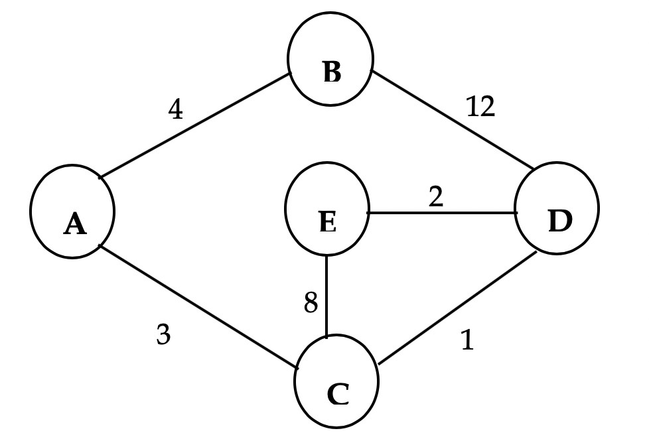

Figure 3: A graph of five routers with cost on each link. Run Distance Vector algorithm on the graph

To resolve the count-to-infinity problem, each node tells its neighbors that it has an infinite distance to any destination it learned about through them. This prevents routing loops. Nodes exchange and update their distance vectors, and with poisoned reverse, they will converge within 4 iterations as a result of the longest path of D to B which would be converged to 1+3+4=8.

1. **Distance Vector Routing (10 points).** Consider the 5-node network shown in Fig. 3. Suppose that each node knows the costs to its neighbors. The distance vector algorithm is used by all the nodes. What is the initial distance vector table at node *D*? You only need to list the initial distance vector table at node *D*; no need to show any later steps.

Intital Network: Fig. 3

Inital distance vectors:

|  |  |  |  |  |  |
| --- | --- | --- | --- | --- | --- |
|  | Node A: | Node B: | Node C: | Node D: | Node E: |
| A | 0 | 4 | 3 | inf | inf |
| B | 4 | 0 | inf | 12 | inf |
| C | 3 | inf | 0 | 1 | 8 |
| D | inf | 12 | 1 | 0 | 2 |
| E | inf | inf | 8 | 2 | 0 |

1. **Wireshark Lab (15 points).** Do problems 1-7 in the IP wireshark lab (posted in HuskyCT).

1. 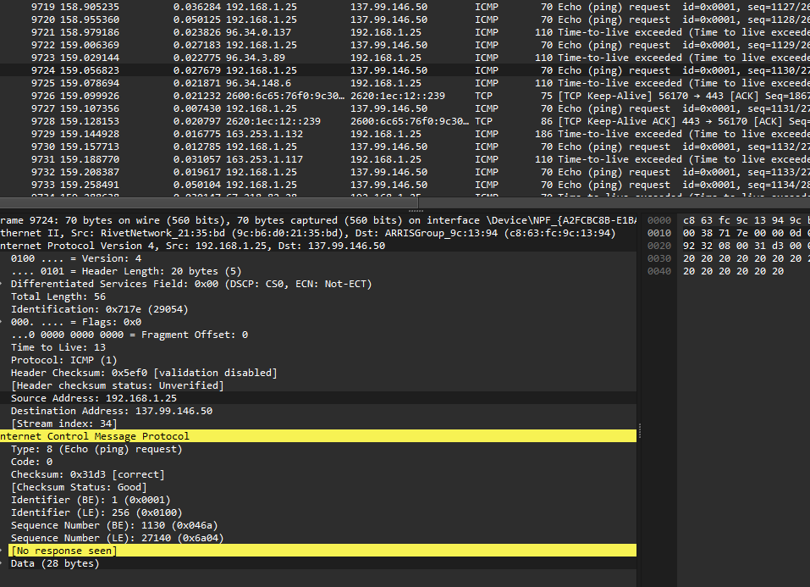Source Address: 192.168.1.25

2.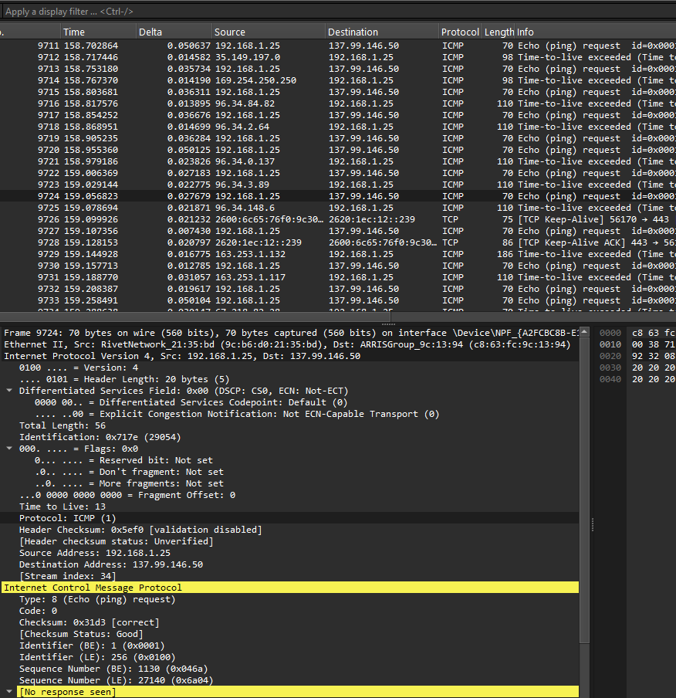

Protocol: ICMP (1)

3.Bytes in header and payload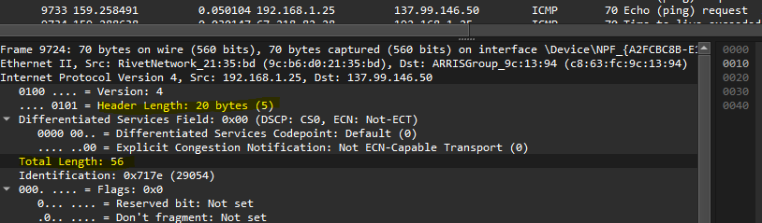

4.Fragmentation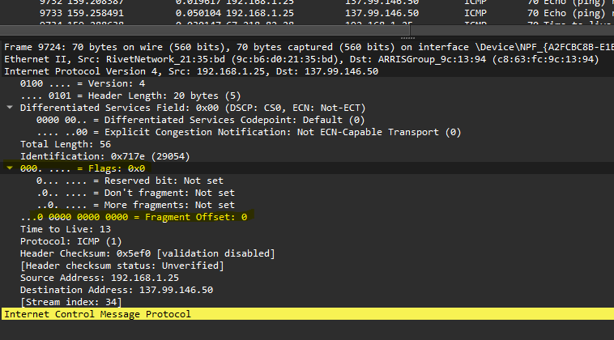

5.Fields that change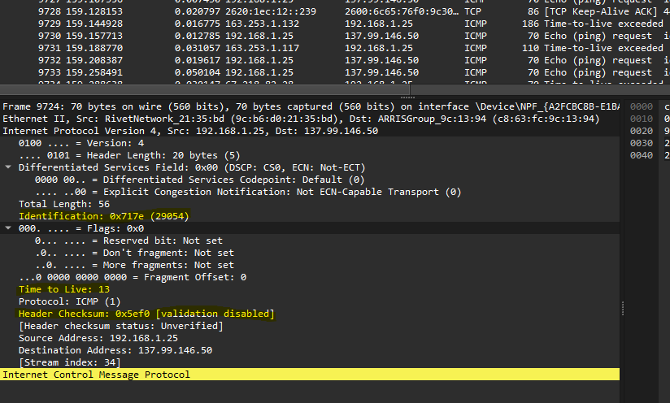

6.Fields that remain constant 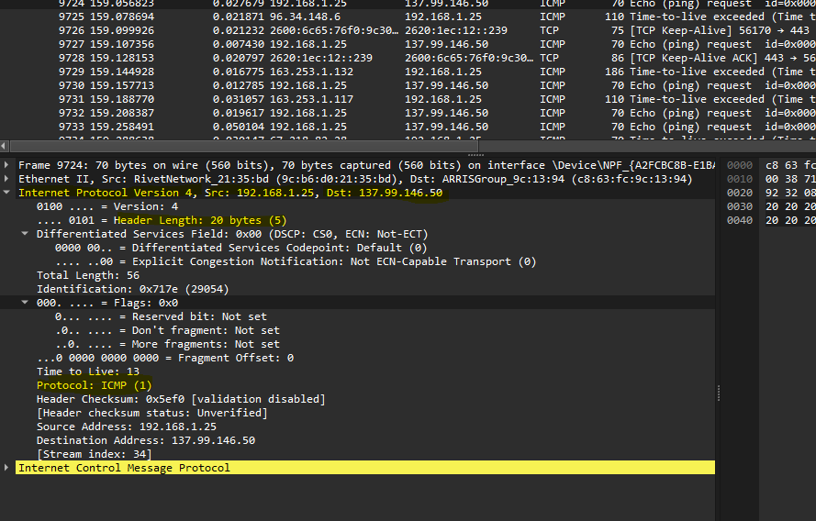

7. Patterns in identification field

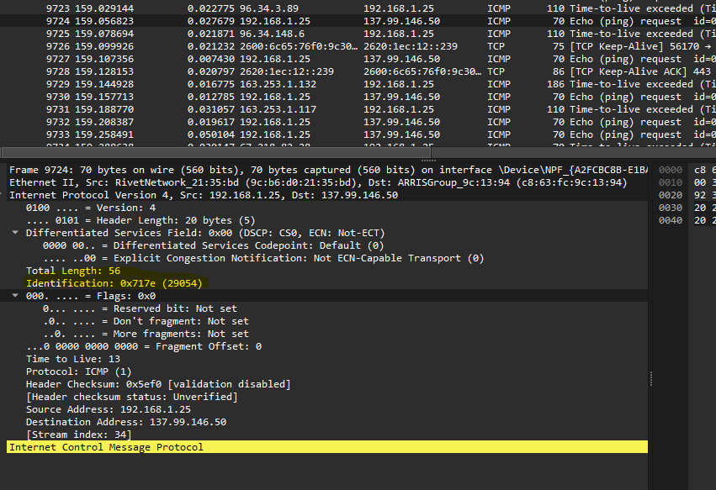

ProviderCustomer PeerPeer

B

A

w

x

C

z

y

Figure 4: Network topology (edges are marked with AS relationships).

1. **BGP.** (15 points) Consider Fig. 4, where provider-to-customer relationship is shown as a directed edge pointing from the provider to the customer, and peer-to-peer relationship is represented by an undirected edge. In this figure, B and C have a peer-to-peer relationship. A is a customer of both B and C. ASes x and y are customers of A, w is a customer of B, and z is a customer of C.
   1. (5 points) Suppose A would like to have the traffic destined to x to come from either B or C. In addition, suppose that A would like to have the traffic destined to y to come from B only. What should A advertise to B and C?

A should advertise the route to x to both B and C, This way traffic to x can come to either B or C.

A should only advertise y to B. This will make all traffic for y will come from B, as C will have no idea how to route traffic for y.

* 1. (5 points) Suppose A would like to route x’s traffic to destination z via either B or C,while route x’s traffic to destination w via only B. What should A advertise to B and C?

A should adversite the route to z to both B and C. This allows traffic from x to reach z via either B or C.

A should only advertise the route of w to B. allowing from x’s traffic to w be exclusive to B.

* 1. (5 points) Suppose y advertises its prefix to A by sending A a BGP announcement.Would A forward the announcement to x? If so, what announcement is forwarded to x? Write the announcement in terms of prefix and AS-path. Suppose y’s prefix is p.

Yes A would forward the BGP announcement from y to x.

AnnouncementL

Prefix: p

AS-path: A y

(Hint: In BGP, an AS A forwards an announcement received from a customer to all A’s neighbors, so as to get more revenue for transiting traffic to the customer.)